**QUESTION 1**

1. The list is given in the question and sort() method is used for sorting.
2. Inbuilt min() and max() method is used to add the min age and max age.
3. To find the median and mean , statistics has been imported and statistics.median() and statistics.mean() are used.
4. For range, did the subtraction.

**QUESTION 2**

1. Created an empty dictionary called as ‘Dog’ as the dict rep as {}.
2. Added the keys and values to the dictionary.
3. Created an another dictionary for students along with the keys and values.
4. By using len() method, found the len of dict.
5. To know the data type of a key, type() method has been used.

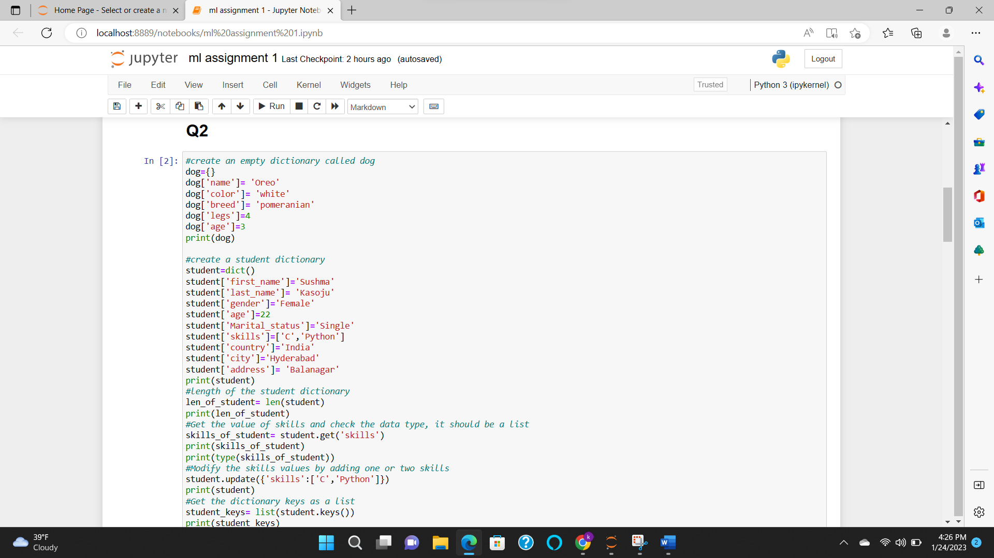

**QUESTION 3**

1. Created two tuples and created a new variable sibling and joined both the tuple by using ‘+’ sign.
2. Using count(), found the length of the tuple.
3. As per the question, added fathers and mothers name to the siblings tuple by creating new variable as family members and added both the tuples.

**QUESTION 4**

1. For the given set in the question , found the length of the set by using len() method.
2. Used add() method to add an element to the set.
3. update([]) method has been used for adding multiple elements in to the sets.
4. Remove() method has been used for removing an element.
5. Union, intersection, issubset(), isdisjoint() , symmetric difference() methods has been used.
6. To find the length, len() method is used.

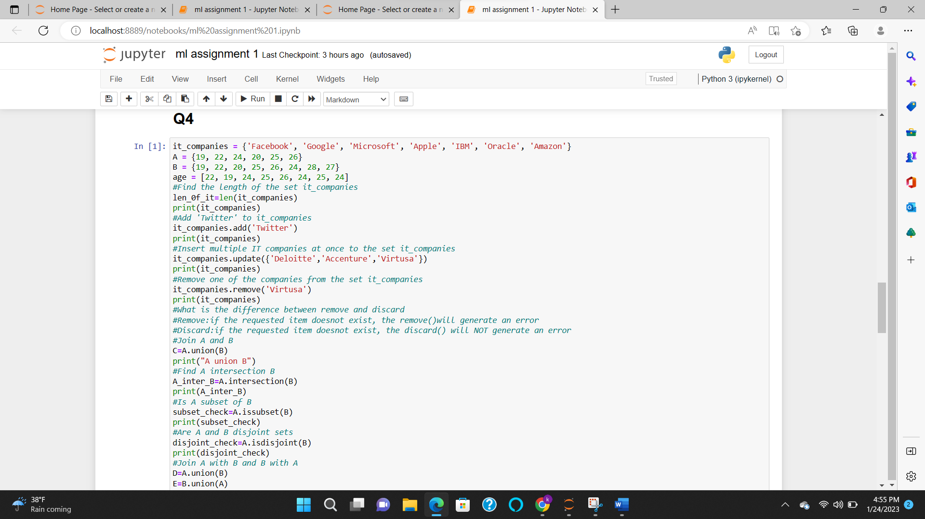

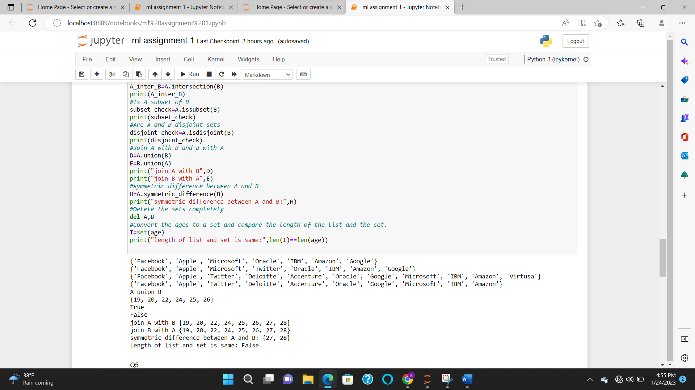

**QUESTION 5**

1. The question says to give 30 as Input and I imported math .
2. Area of the circle and circumference of the circle had been defined by the formula for area and circumference .

**QUESTION 6**

1. Split() method is used for getting the individual elements.
2. Len() method is used to find the length.

**QUESTION 7**

1. I have used ‘\t’ to create the required spacing between the header names and printed.

**QUESTION 8**

1. Created a variable ‘radius’ to store the radius of a circle as 10.
2. Created a variable ‘area’ with the given formula to calculate area.
3. Printed the area value using string format.

**QUESTION 9**

1. Used for loop , added the required formula in for loop to convert the weights in to kilometers .
2. Printed the list kgs as shown.

**QUESTION 10**